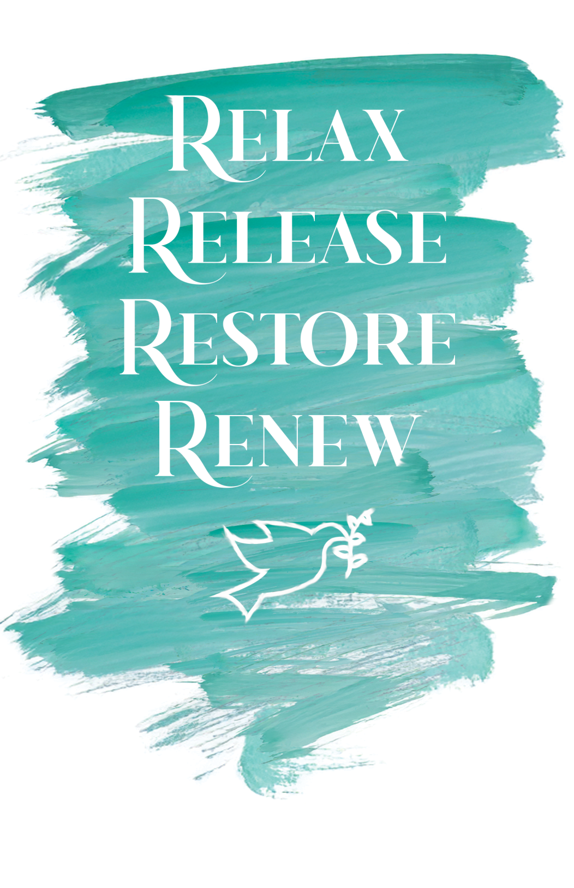

This booklet from our small library is provided to you free of charge. If you would like to share it with another, please send them to our site – LifeRegeneration.net - versus just giving them your copy (whether physical or digital copy). This will help spread the information in this library as well as the services available at LifeRegeneration, enabling us to spend more time producing book/booklets to share.

Also, if you’d like to support this library and this ministry and its growth, please consider giving a donation to LifeRegeneration for this purpose ([Living and Giving](https://liferegeneration9.wixsite.com/energy-healing/giving)).

Cover Design by Gabriel Kraft 2025

**Disclaimer:**

What is presented here has not been approved by the FDA, the AMA, the CDC or any other government agency. It is merely for educational purposes. By reading this booklet you agree that you understand this and take responsibility for your own decisions and health care choices.

LifeRegeneration

Personal Peace Process

The Personal Peace Process that I'm about to unfold for you is not just a way to "feel a little more peaceful." Properly understood, this technique should be the healing centerpiece for every person on earth. Every physician, therapist, spiritual counselor and personal performance coach in the world should be using it as a leading tool for helping others (and themselves).

In essence, the Personal Peace Process involves making a list of every bothersome **specific event** in one's life and systematically LRMT'ing (LifeRegeneration Meridian Techniques) their impact out of existence. By diligently doing this we can pull out every negative tree from our emotional forests and thus eliminate major causes of our emotional and physical ailments. In essence cut down an infected, diseased forest of trees and replant the area with a healthy, vibrant, beautiful forest. This, of course, propels each individual toward personal peace which, in turn, contributes to their physical, spiritual and emotional health and the lives of those around them, and ultimately the world.

This is NOT meditation - emptying self, focusing on energy or emotions. It IS looking at our heart issues and giving them to God by admitting any weakness/sin/negative issue(s) and asking HIM to take it and replace it with what He directs and instructs in His Word. Be open, be honest with God.

It may be used:

1. As "homework" between sessions with a physician, therapist, or energy consultant at LifeRegeneration. This is certain to accelerate and deepen the healing process.

2. As a daily Process to clear out a lifetime of accumulated emotional debris. This will enhance self-image, reduce self-doubt and provide a profound realization of freedom. Hopefully, it will draw you closer to God. If you can’t find time to do it every day, then at least commit to 3 days a week.

3. As a means to eliminate a major contributor (if not the sole cause) of a serious disease. Somewhere within one's specific events are those angers, fears and traumas that are manifesting as disease. By addressing them all, you will likely cover those heart issues responsible for the disease.

4. As a useful substitute for finding core issues. If you neutralize all the specific issues you will have automatically included core issues.

5. As a means for consistent relaxation.

6. To become an example to others as to what is possible.

The Personal Peace Process concept should shift the entire healing field. I can state it in a sentence...

**Most of our emotional and physical problems are caused, or contributed to, by our unresolved specific events, the vast majority of which can be easily handled by LRMT or other techniques which resolve/release trapped emotions from our bodies.**

That sentence, if adopted by every healing practitioner and patient, would likely (1) dramatically increase our healing rates while (2) precipitously dropping our costs. Please note that this idea completely ignores chemical causes such as those propounded by the medical model. That's because I have repeatedly seen improvements in clients where drugs and other chemical solutions have failed miserably. This is not to say, however, that drugs, proper nutrition and the like don't have their place. Indeed they do and can often be vital. In my experience, however, our unresolved specific events are nearer the foundational cause for illness than anything else. Thus they deserve our primary attention.

How obvious! Experienced LRMTers are well aware of LRMT's ability to cleanly wipe the negative specific events off of our mental walls. This is the area wherein our highest success ratios appear. To date, however, we have focused our efforts on those negative specific events that underlie a given ailment such as a phobia, headache or traumatic incident. This is good...very good...and we should continue doing so.

On the other hand, why not use LRMT on ALL the other specific events that are behind our more generalized (but VERY important) issues such as (to name a few)....

Anxiety

Depression

Persistent insomnia

Addictions

Compulsions

Feelings of abandonment

Physical maladies

As you eliminate the emotional baggage from your specific events you will, of course, have less and less internal conflict for your system to deal with. Less internal conflict translates into a higher level of personal peace and less emotional and physical suffering. For many, this Process will likely result in the complete cessation of lifelong issues that other methods have not touched. How's that for peace in a paragraph?

The same applies to physical ailments as well. I'm talking here about everything from headaches, breathing difficulties, heart attacks, and digestive disorders to AIDS, MS and Cancer. It is becoming more widely accepted that our physical maladies are caused (or contributed to) by unresolved angers, traumas, guilt, unforgiveness, grief, fears and the like. I have had many discussions with physicians in recent years and more and more of them echo emotional strife/stressors as a major cause of serious diseases. Until now, however, there hasn't been an effective way to eliminate these health bandits. We can mask them with drugs, of course, but true cures have been hard to find. Fortunately, LRMT and its many cousins now provide easy and elegant tools that will aid the serious health practitioner in killing the root causes of disease...instead of the patient.

What I share here is NOT a substitute for quality training NOR is it a substitute for quality help from an experienced LRMT practitioner. Rather, it is a tool that, properly applied, is capable of wide-ranging relief (quality training or quality assistance will add to its effectiveness). Its simplicity and far-reaching effectiveness give it candidacy as a mandatory method for anyone seeking help for even the most difficult of problems. I know that's a bold statement but I've been at this for almost two decades now and have seen so many impressive results over such a wide variety of issues that this statement is easy, if not essential, to make.

The method here is simple and I'm assuming you already know how to apply LRMT (are familiar with the tapping points on the upper body, on the fingers and hands, and extra points you can learn from your LRMT consultant). If not, click on this link and learn the basic points. The order is not important, just that you catch them all.

[Come and See! Learn the Tapping Points with Jessica Ortner](http://liferegeneration9.wixsite.com/energy-healing/come-and-see)

If you have not used meridian tapping before, please, please, please call and schedule a tapping session with LifeRegeneration before beginning this Personal Peace Process (or another trained EFT consultant or professional). We can work with you in our office or long distance over the phone (when you call from a quiet place where you will not be disturbed). I can even do a messenger chat/video session if you prefer to see who you’re working with.

**Finally, here is the step-by-step Personal Peace Process:**

A. Begin with a notebook you will designate solely for this process – either a spiral, one subject, 70- to 100-page one or a three ring binder with at least 50 pages in it if not more.

B. Read the whole process below before you begin writing.

C. For those who desire, pray asking God to give you wisdom, an open mind, and the ability to complete the process.

D. You might only spend one-half hour to an hour each day working on this list. That’s okay. You do not need to write your list in one sitting. My list took me a few days to write initially. You can also spend all day on it if you desire. Just make sure that if you feel stress or tiredness, stop and do rounds of tapping until you bring the intensity of your stress or tiredness down below a 3 and then put your list away for another day.

E. Write down any main issues you wish to work on – physical, spiritual, relational, job related, etcetera. Make sure you write what you want to see happen versus what you don’t want. i.e. “I want to feel healthy and have great blood pressure,” vs. “I am tired of being sick and don’t want any more high blood pressure readings.” ANOTHER EXAMPLE: “I would like to be able to handle my days in a positive mindset,” versus “I don’t want to have to deal with any more angry situations.”

(Philippians 4:8)

F. NOW, we just told you to keep positive but there is a time and place to bring up the stressors, issues, and problems that you want to deal with and invite God to help you resolve these and put them away once and for all. This is how you guard your heart – reveal the issues, bring them to God and resolve them vs. stuffing them, putting them on a shelf, or covering them over. (Proverbs 4:23)

G. Apply forgiveness liberally and from every angle. What do I mean by this? When looking at an issue consider if you need to:

1) Forgive someone for something they did or said

2) Consider if you’d like someone to forgive you for something

3) Ask God to forgive you and receive that

4) Forgive yourself for any reason

YES! Forgiveness is a vital part of what God instructs us to do and can often be a major cause of maladies. PRACTICE FORGIVENESS DAILY.

Now, on to your actual PPP (Personal Peace Process) notebook:

**1. Make a list of every bothersome specific event you can remember** (After you finish reading these steps on how to do this).

After writing down at least 20 issues, you may continue with the steps. More issues will surface as you do; as they do come to mind, stop and write them each on their own line of your list, then come back to the issues you are working on.

If you don't end up with at least 50 lines in your notebook you are either going at this half-heartedly or you have been living on some other planet. Most people find at least 200-300 and some people will write down over 500, no kidding. You are not alone. List any negative situation your mind comes up with or even jumps to unbidden.

**2.** While making your list you may find that **some events don't seem to cause you any current discomfort. That's OK. List them anyway**. The mere fact that you remember them suggests a need for resolution. If you know it’s a negative event from your life – present or past – write it down. **Include the tiny little things** that may have just frustrated you at the time, even those things you have put aside as not important or things that you think you have already dealt with. The fact that you remember something negative means you may have to still clear it totally.

**3. Give each specific event a title**....as though it was a mini-movie. Examples: Dad hit me in the kitchen--I stole Suzie's sandwich--I almost slipped and fell into the Grand Canyon--My third grade class ridiculed me when I gave that speech--Mom locked me in a closet for 2 days--Mrs. Adams told me I was stupid, etcetera.

3b. While writing this list down in your binder, make each event or memory **one line** (versus writing down all the details). Literally, **keep it to one line of your notebook**.

**4. When writing down your list, write on one line then leave 2 to 3 lines empty**, before writing another incident/event. You’re not trying to economize on paper here. These empty lines will be used later.

**5. When the list is complete, rate each issue.** Don’t belabor the process, just allow your mind to quickly pick a rating, jot the number on the first line under your “title” or listing, and move on to the next one.

**6. Now, pick out the biggest trees in your negative forest and apply LRMT to each** of them until you either laugh about it or "can't think about it anymore." Be sure to notice any aspects (other ideas or issues) that may come up in the middle of tapping, jot them down quickly in your list on their own line, and go back to the issue you are tapping on until done. You can consider these side issues as separate trees in your negative forest. Apply LRMT to them accordingly. Be sure to keep after each event until it is resolved.

If you cannot get a 0-10 intensity level on a particular movie then assume you are repressing it and apply 10 full rounds of LRMT on it from every angle you can think of, mentally perceiving it from different angles. This gives you a high possibility for resolving it.

**Make sure** you rate the intensity, drink water, and do your 4:6 breathing after each round and note the changes. After the big trees have been removed, go to the next biggest trees.

**7. Do at least one movie (specific event) per day...preferably three...for 3 months.** WHAT!? Yes, it only takes minutes per day. At this rate you will have resolved 90 to 270 specific events in 3 months.

Now, **be aware that your body as a whole – body, spirit, mind, and heart – can usually only handle up to 4 issues a day, most likely 2-3.**  If you are on a marathon to clear these you will short circuit the process and your results will not be beneficial.

I had a client who wrote down 100s of issues and “cleared” them in less than a week . . . or at least she felt that she had. Her physical problems were still present and her body was tired. Our systems cannot properly handle that much energy moving in such a short time! **Keep your tapping to 1-3 issues a day.**

Notice along the way how your body feels better. Note, too, how your "threshold for getting upset" is much lower and your “buttons” get pushed less and less if not at all. Note how your relationships are better and how many of your therapy-type issues just don't seem to be there anymore. Revisit some of those specific events and notice how those previously intense incidences have faded into nothingness. Note any improvements in your blood pressure, pulse and breathing ability.

I ask you to consciously notice these things and write the intensity down because, unless you do, the quality healing you will have undergone will seem so subtle that you may not notice it. You may even dismiss it saying, "Oh well, it was never much of a problem anyway." This happens repeatedly with LRMT and this is why I bring it to your awareness.

**8. If you are taking medications, you may feel the need to discontinue them. Please do so ONLY under a qualified physician’s advice.**

**Second Level Personal Peace Helps**

One help in completing your personal peace list in your notebook is to access the Jubilee Options App if only to access the sample and use the Trapped Emotions Chart and the Jubilee Options Chart for perusing the lists there and see what jumps out at you and jogs a memory or feeling:

<https://liferegeneration9.wixsite.com/energy-healing/copy-of-trapped-emotions>

<https://liferegeneration9.wixsite.com/energy-healing/copy-of-jubilee>

It is my hope that the Personal Peace Process becomes a world-wide routine. A few minutes per day will make a monumental difference in school or work performance, relationships, health and your quality of life. But these are meaningless words unless you put the idea into practice.

If you are curious how I used this Personal Peace Process, feel free to get the free booklet from the LifeRegeneration library entitled, “Journey Out of a Medical Prognosis.” It literally took me a year to complete my PPP binder, without the help of a hands-on consultant. With your LifeRegeneration consultant it can take you much less time to overcome the challenges you face.

I conclude this with a few wise words that show how important peace is to all the issues of our lives – relationships, work, goals, physical health, ministry, and everything we create in our lives.

**Third Level Personal Peace Helps**

Meditation is not an eastern religion concept that they created. God tells us to meditate on the Word vs. ooohmming and emptying our mind while relaxing our body. Do not use this counterfeit or practice it; instead learn the meditation God instructs us to do daily.

I once had a pastor tell me that he doesn’t even touch meditation because he equates it with middle-eastern religion and stays far away from it. How sad that he has allowed Satan to steal this practice that God encourages us to do, all because he does not realize that we do not need to submit to a counterfeit, but we should not cease meditating altogether. Do you stop using money because there are counterfeits out there?

God tells us to meditate on the Word. You can learn more detail on this by reading the Bible and the LifeRegeneration booklet, “Meditate on Truth Not Counterfeits,” (still in the writing phase).

Here is just a start on your study of scripture to find the specific area that encourage us to follow God with our whole heart and our whole mind and follow Him, listening to the Holy Spirit and being aware that, “If you love Him, you will obey Him,” because he made you and knows what your specific purpose is in life.

Enjoy your personal peace journey:

Jesus answered him, “The first of all the commandments is: *‘Hear, O Israel, the LORD our God, the LORD is one*. *And you shall* *love the LORD your God with all your heart, with all your soul, with all your mind, and with all your strength.’”* Mark 12: 29-30 / Deuteronomy 6: 4-5

“Keep your heart with all diligence, for out of it *spring* the issues of life.” [Diligence = above all things; Keep = guard]. (“Be careful what you think, because your thoughts run your life.” NCV) Proverbs 4:23

Above all things, with all diligence **guard your heart, for from it flow the issues of life.** Prov. 4:23

Be anxious for nothing, but in all things by prayer and supplication with thanksgiving make your requests known to God, and the peace of God that passes all understanding **will guard your hearts and minds** through Christ Jesus. Philippians 4:6-7

*There is* no soundness in my flesh Because of Your anger, Nor *any* **health** in my bones Because of my sin. Psalm 38:3

The light of the eyes rejoices the heart, *And* a good report makes the bones **health**y. Proverbs 15:30

A **merry** **heart** does good, *like* medicine, But a broken spirit dries the bones. Proverbs 17:22

“And be kind to one another, tenderhearted, **forgiving** one another, even as God in Christ forgave you.” Ephesians 4:32

Personal Peace to You!

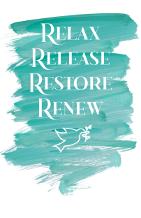

LifeRegeneration  
Relax Release Restore Renew: Personal Peace Process  
©2010, 4th Edition 2025

Cover Design by Gabriel Kraft 2025

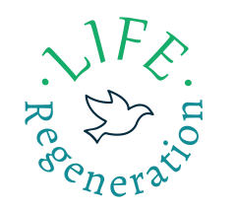  
“We are fearfully and wonderfully made!”  
 *Holistic // Complementary // Heart ~ Spirit ~ Mind ~ Body*[www.LifeRegeneration.net](http://www.LifeRegeneration.net)